# GameSpot

## Definition

**# Source**: **Windows ScreenShots From Site -> https://www.gamespot.com/ at [8/27/2025]**



**# Source**: **Chatgpt (GPT-5-Standard) at [8/27/2025]**

**GameSpot** is a popular online platform and YouTube channel dedicated to **video game news, reviews, previews, and entertainment**. It provides gamers with updates on new releases, industry trends, walkthroughs, and gameplay videos.

## Key Highlights

**# Source**: **Chatgpt (GPT-5-Standard) at [8/27/2025]**

* Founded in **1996** as a video game news website.
* Offers **game reviews, previews, news, and walkthroughs**.
* Covers **all gaming platforms**: PC, consoles, and mobile.
* Features **YouTube content** like trailers, gameplay, and commentary.
* Known as a **trusted source for gaming information** in the gaming community.

## Summary Table

**# Source**: **Chatgpt (GPT-5-Standard) at [8/27/2025]**

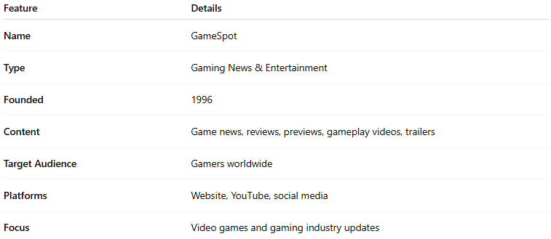

| **Feature** | **Details** |
| --- | --- |
| **Name** | GameSpot |
| **Type** | Gaming News & Entertainment |
| **Founded** | 1996 |
| **Content** | Game news, reviews, previews, gameplay videos, trailers |
| **Target Audience** | Gamers worldwide |
| **Platforms** | Website, YouTube, social media |
| **Focus** | Video games and gaming industry updates |